**Capstone Project-The-Battle-of-Neighborhoods|**

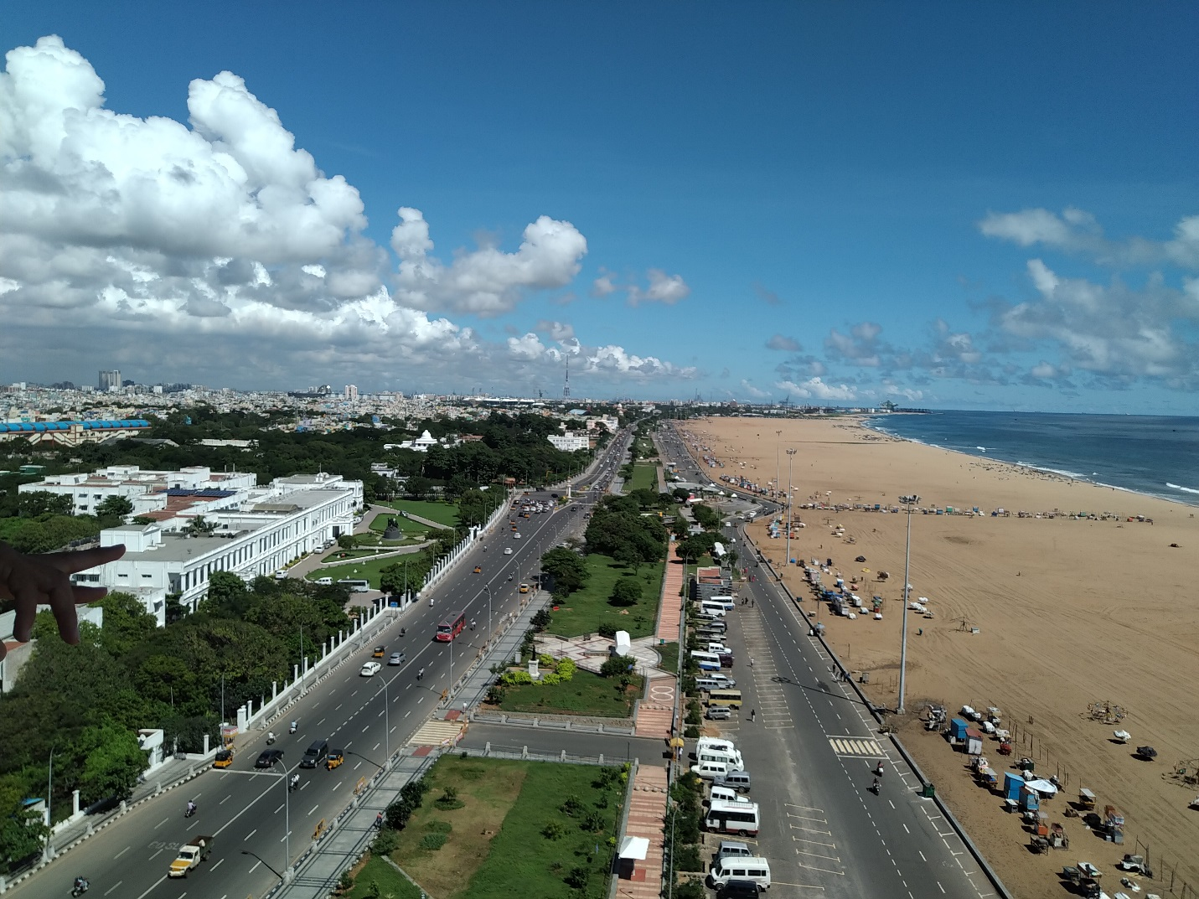**Exploring Chennai, Tamil Nadu, India**

1. **Introduction:**

Chennai, the capital city of Tamil Nadu- India, attracts many visitors either as tourists or as part of its large workforce. The vast majority claim Chennai is one of the best cities in India. We know that Chennai is popular for IIT and for being an IT and industrial hub. The city is also renowned for its passion for music. But, there’s more to the city than you think. From its varied culture and tradition, vibrant festivals, dainty delicacies to its quintessential “Chennai Tamil”, this city doesn’t fail to mesmerize the locals and the outsiders living here.

**1.1. Business Problem:**

The expectation of visitors to Chennai could be stated as follows:

a. What are the local food/ native cuisine available from restaurants in and around Chennai?

b. What services or value addition does the stop-over at a restaurant bring him, other than enjoying good food?

**1.2 Target Audience:**

1.2.1 The goal of this exercise is to give a simple recommendation to visitors of Chennai, Tamil Nadu: in which area they will find a large number or concentration of which types of restaurants.

1.2.2 The target audience are investors who would like to start a group or chain of restaurants in and around Chennai. This analysis will give an idea, which area is crowded with restaurants and where is it beneficial to open a restaurant around Chennai.

1.2.3 Road Travelers, to find reasonable refreshment joint where they can dine and also get along to refresh themselves in an amusement park – rest and refresh during their long road trip.